**Final Report of Traineeship Program 2024**

“Analyse Company's Performance using Ratios”



MEDTOUREASY

28/08/2024

**ACKNOWLEDGEMENTS**

The traineeship opportunity that I had with MedTourEasy was a great change for learning and understanding the intricacies of the subject of Data Visualizations in Data Analytics; and also, for personal as well as professional development. I am very obliged for having a chance to interact with so many professionals who guided me throughout the traineeship project and made it a great learning curve for me. Firstly, I express my deepest gratitude and special thanks to the Training & Development Team of MedTourEasy who gave me an opportunity to carry out my traineeship at their esteemed organization. Also, I express my thanks to my mentor Ankit Hasija for making me understand the details of the Data Analytics profile and training me in the same so that I can carry out the project properly and with maximum client satisfaction and also for spearing his valuable time in spite of his busy schedule.

**TABLE OF CONTENTS**

1 **Introduction**

1.1 About the Company

1.2 About the Project

1.3 Objectives and Deliverables

2 **Methodology**

2.1 Flow of the Project

2.2 Use Case Diagram

2.3 Tools Used

3 **Implementation**

3.1 Gathering Requirements and Defining Problem Statement

3.2 Data Collection and Importing

3.3 Data Cleaning and Data Filtering

3.4 Data visualization and Development of Dashboards

4 **Sample Screenshots and Observations**

4.1 Profitability Analysis

4.2 Liquidity Analysis

4.3 Activity Analysis

4.4 Solvency Analysis

5 **Conclusion**

6 **Future Scope**

7 **References**

1 INTRODUCTION

* 1. About the Company

MedTourEasy, a global healthcare company, provides you the informational resources needed to evaluate your global options. MedTourEasy provides analytical solutions to our partner healthcare providers globally.

* 1. About the Project  
       
     The purpose of this project is to analyse the financial performance of two major automotive companies, BMW and Volkswagen, over the period from 2016 to 2019. The dataset includes the income statements, balance sheets, and cash flow statements for both companies.   
       
     By calculating and comparing key performance ratios—such as profitability, solvency, liquidity, and activity ratios—this analysis aims to uncover trends and insights into the financial health and operational efficiency of each company and how they have evolved from 2016 to 2019.
  2. Objectives and Deliverables  
       
     This project focuses on creating easily understandable, interactive and dynamic dashboards by gathering data of the performance ratios of BMW and Volkswagen over the years 2016 to 2019 from the dataset being analysed which is available on: -  
       
     <https://docs.google.com/spreadsheets/d/e/2PACX-1vTjcQJJAzAF6zzJrmKiKLc8BVlkTVGmz_pBN3ZACAK3QWuM0fWIm3IfAkChwUt1JjtJywz2Fnz4aFVP/pubhtml>  
       
     The dashboards will be created on Power Bi which will allow the firm to plot dynamic visualizations and analyse the performance of the two companies.  
       
       
       
     The project will consist of 4 dashboards detailed as follows(4 deliverables):  
       
     a. **Profitability Analysis**: This dashboard focuses on analysing the profitability ratios of the two companies. This is a measure of a company’s ability to generate profit relative to sales, assets, and equity.  
       
      - Return on Capital Employed (ROCE): (Operating Profit/Capital Employed)%  
      - Return on Sales (ROS): (Operating Profit/Revenue)%  
      - Gross Profit Margin: (Gross Profit/Revenue)%  
       
     b. **Liquidity Analysis**: This dashboard focuses on analysing the liquidity ratios of the two companies. This is a measure of a company’s ability to meet its short-term obligations.  
       
      - Current Ratio: (Current Assets/Current liabilities)  
      - Quick Ratio: (Current Assets – Inventory)/Current liabilities  
       
     c. **Solvency Analysis**: This dashboard focuses on analysing the solvency ratios of the two companies. This is a measure of a company’s ability to meet its long-term obligations and ensure long-term financial stability.  
       
      - Debt-to-equity Ratio: (Total debt/Total Equity)  
      - Interest Cover: (Operating profit/finance costs)  
       
     d**. Activity Analysis:** This dashboard focuses on analysing the activity ratios of the two companies. This is a measure of how efficiently a company utilizes its assets to generate revenue.  
       
      - Asset Turnover: Revenue/(Non-current liabilities+Total equity)  
      - Receivable Days: Receivables/(Credit Sales x 365 days)  
      - Inventory Days: Inventory/(Cost of sales x 365 days)  
      - Payable Days: Payables/(Cost of sales x 365 days)

1. METHODOLOGY
   1. Flow of the Project  
        
        
      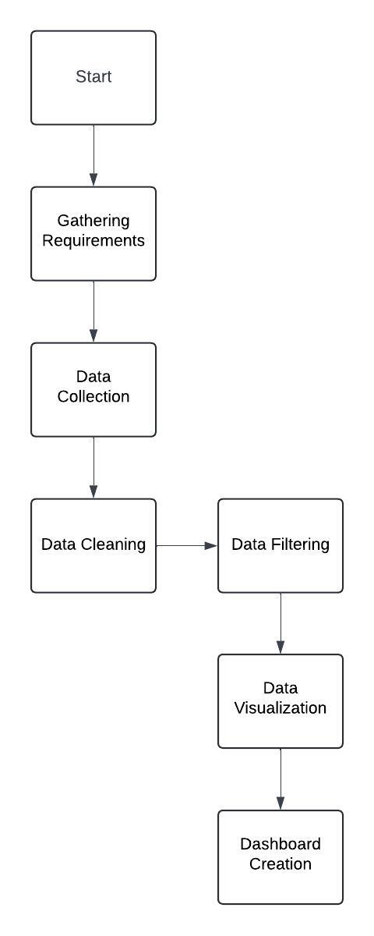
   2. Use Case Diagram  
        
        
      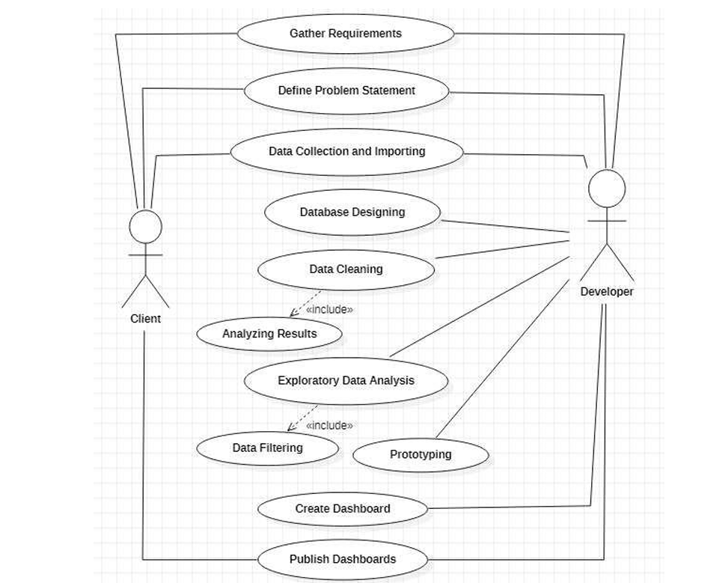  
        
        
      Above figure shows the use case of the project. There are two main actors in the same: The Client and Developer. The developer will first gather requirements and define the problem statement then collecting the required data and importing it. Then the developer will design databases so as to identify various constraints and relations in the data. Next step is to clean the data to remove irregular values, blank values etc. Next, exploratory data analysis is conducted to filter the data according to the requirements of the project. Then a prototype of the dashboards is created using Power BI to get a clear view of the visualizations to be developed. Finally, dashboard is developed and analysed to publish the results to the client.

* 1. Tools Used:  
       
     - Microsoft Power Bi: Power BI is a powerful data visualization tool by Microsoft that allows users to create interactive reports and dashboards. In this project, Power Bi is used to import the data from the url and clean it in such a way that it can be analysed and visualised.  
       
     - Microsoft Word: Microsoft Word is a versatile word processing application by Microsoft that enables users to create, edit, and format documents with ease. The report for this project is created in Microsoft Word and the screenshots of all the charts generated in Power BI are shown along with the analysis and text descriptions.

1. IMPLEMENTATION
   1. Gathering Requirements and Defining Problem Statement   
        
      This is the first step wherein the requirements are collected from the clients to understand the deliverables and goals to be achieved after which a problem statement is defined which has to be adhered to while development of the project.
   2. Data Collection and Importing  
        
      Data collection is a systematic approach for gathering and measuring information. The dataset for this project is collected from <https://docs.google.com/spreadsheets/d/e/2PACX-1vTjcQJJAzAF6zzJrmKiKLc8BVlkTVGmz_pBN3ZACAK3QWuM0fWIm3IfAkChwUt1JjtJywz2Fnz4aFVP/pubhtml>  
        
      The link contains the Income statement, Balance sheet and Cash Flow Statement for BMW and Volkswagen from 2016 to 2019. We can use this data to calculate all the performance ratios mentioned in the deliverables in the same sheet.  
        
      Now we can import the performance ratios and its values into Power Bi using the Get Data option.  
        
      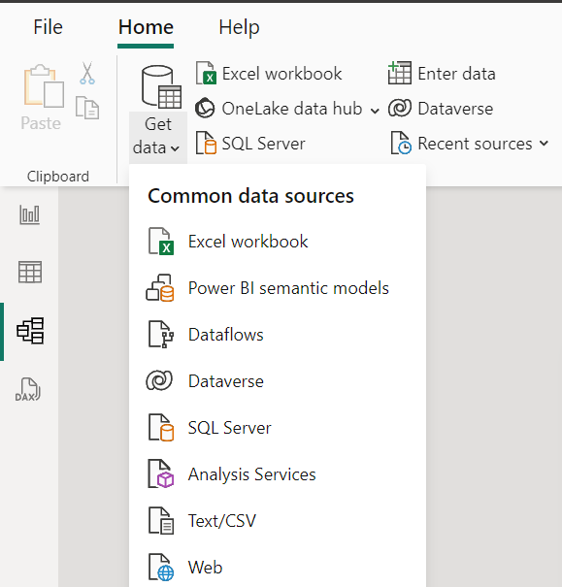  
      Company Performance Ratios(Data to be analysed)  
        
      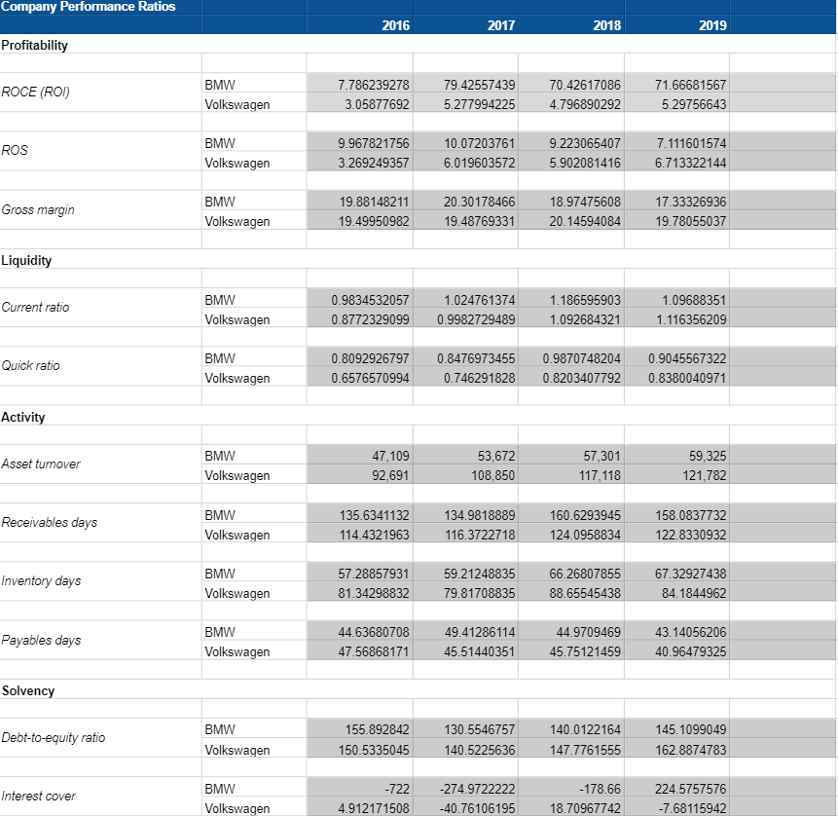
   3. Data Cleaning and Data Filtering  
        
      Data is the most imperative aspect of Analytics and Machine Learning. Everywhere in computing or business, data is required. But many a times, the data may be incomplete, inconsistent or may contain missing values when it comes to the real world. If the data is corrupted then the process may be impeded or inaccurate results may be provided. Data filtering involves selecting specific data points from a dataset based on certain criteria. Hence, Data cleaning and filtering are considered a foundational element of the basic data science.  
        
      With reference to the Performance Ratio Analysis sheet, the sheet contains the values for the Performance Ratios but it also has the income statement and other unnecessary columns which we need to remove before we can analyse the data.  
        
      We can view the imported data in Power Bi by going to *Table View* to understand which columns need to be removed. The *Transform Data* button takes the user to Power Query Editor where the table can be edited and transformed.  
        
      After removing the unnecessary columns and editing out the blank cells in the relevant data, we get the data in this format.  
        
      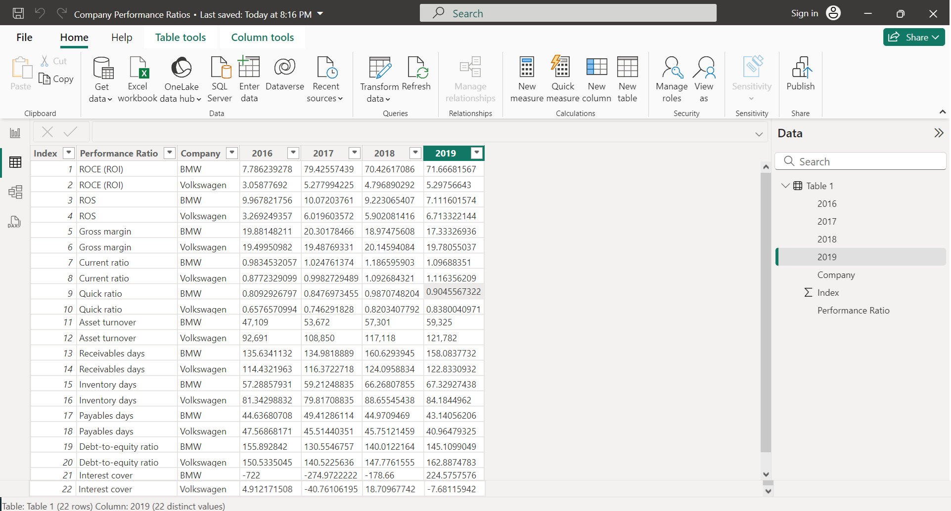  
        
      Note that the first row with the Attribute names is converted to the header for the table using the *Use First Row as Headers* option.  
        
      Now we have the table in a nice, clear format but for the analyses done in this project, the data needs to be cleaned some more. There should be only one column which displays all the performance ratios values instead of 4. Hence, we split the Year columns using *Unpivoted Columns* option in Power Query editor. Now each row has the following columns – Performance Ratio, Company, Year and Value.  
        
        
      Final Data  
        
        
      At this stage, we can consider the Data Cleaning and Filtering to be complete, as in this format we can easily make visualizations and compare each performance ratio for both the companies over the years.  
        
      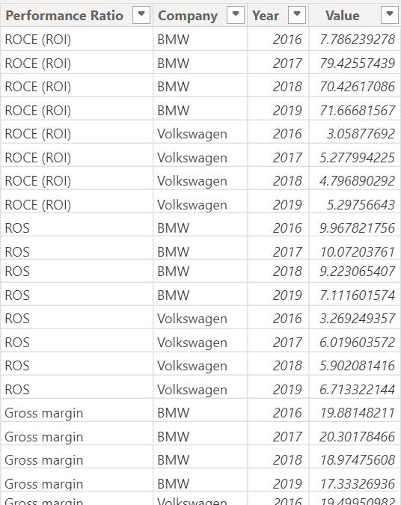  
        
      3.4 Data visualization and Dashboard creation  
        
      Data visualization is presenting data in a graphical or pictorial format. It allows decision-makers to see visually presented analytics, so that they can grasp difficult concepts or identify new patterns. In interactive visualizations, technology can be used to dig in charts and graphs for more detail, interactively modifying what data one can see and how it works.  
        
      Power Bi offers a wide variety of different visualizations which can be selected based on the user’s requirements. For this project, we will select the line chart as it will allow us to effectively plot our data over the years.  
        
        
      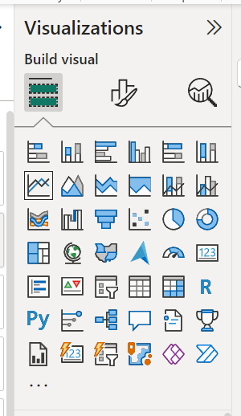  
        
        
        
      After selecting the line chart option, we can specify which columns from our data should be plotted. In this project, the *Year* column is plotted on x-axis and *Value* column on y-axis. Since we are comparing the ratios for two different companies, we can set *Company* column in the Legend field.  
        
      This will give us our desired line chart where the specific performance ratio is shown over the years for both companies. The two lines represent the performance of the two companies.  
        
      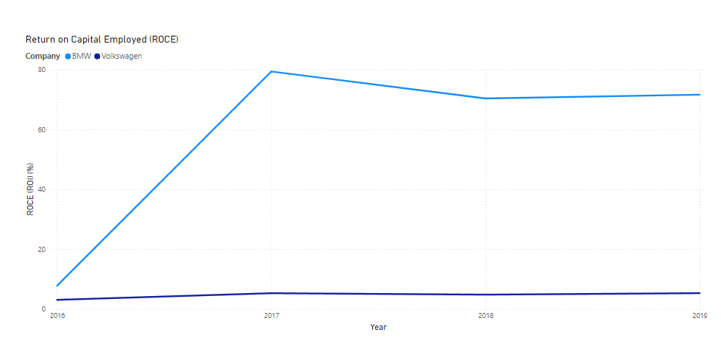  
        
      This chart can be edited further by changing the colour scheme of the background or the colour of the lines. The title and x-axis/y-axis text can also be edited as per requirements. Changing colours and texts in your Power BI graph can significantly enhance its visual appeal, making it more engaging and easier for clients to interpret key insights.  
        
      Slicers in Power BI are visual tools that allow you to filter data in your reports and dashboards. They provide an intuitive way to segment your data by clicking on buttons that represent different categories or values.  
      In this project, slicers are used to cycle through the different performance ratios using buttons in the same chart. This also lets us divide our data into different categories – profitability, liquidity, activity and solvency.  
       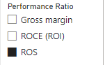  
        
        
      4 SAMPLE SCREENSHOTS AND OBSERVATIONS
   4. Profitability Analysis  
      1. ROCE (Return on Capital Employed):  
           
           
         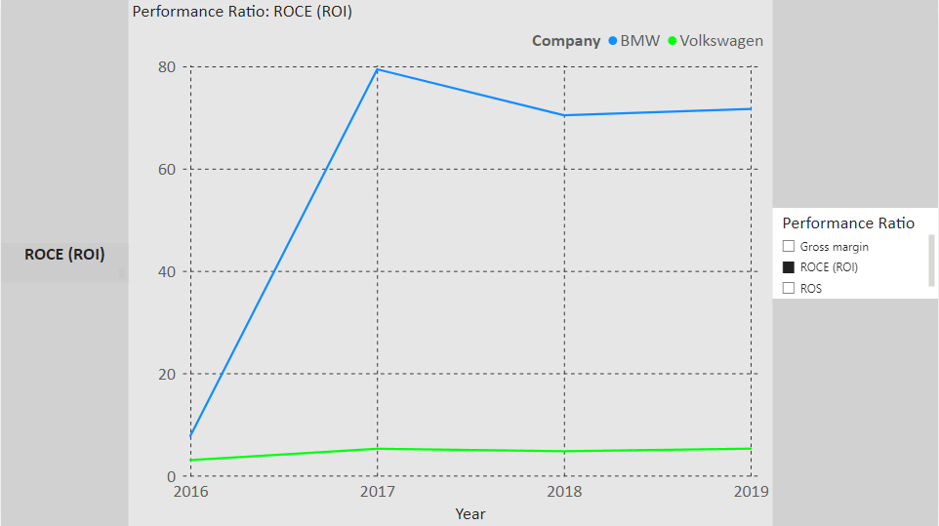  
           
           
         **Observations**:  
           
         - BMW's ROCE shows a significant spike in 2017, reaching almost 80%, before stabilizing around 70% in the subsequent years.

- Volkswagen's ROCE is consistently lower than BMW's, with a gradual increase over the years but staying below 6%.

* + 1. ROS (Return on Sales):  
         
         
       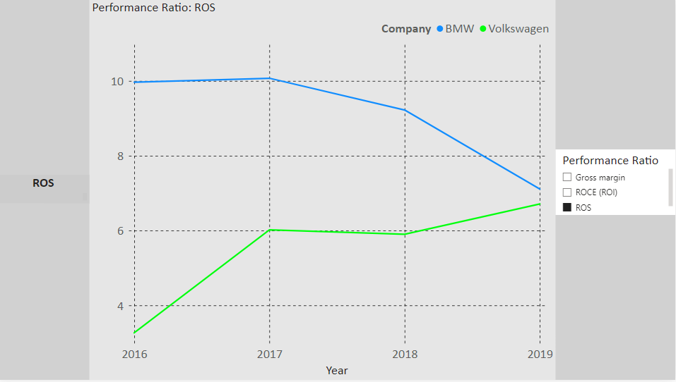  
         
         
       **Observations:**  
       - BMW's ROS slightly declines from 2017 onwards but remains higher than Volkswagen's.  
         
       - Volkswagen shows an increasing trend from 2016 to 2017 but experiences fluctuations afterward, closing the gap with BMW in 2019.

* + 1. Gross Margin:  
         
         
       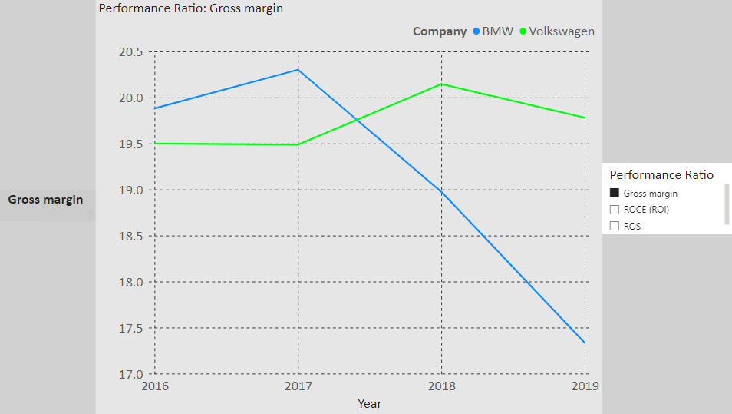  
         
         
       **Observations:**  
       - BMW's gross margin starts higher than Volkswagen's, but it decreases steadily from 2017 to 2019.  
         
       - Volkswagen's gross margin remains relatively stable, slightly surpassing BMW's by 2019.

* 1. Liquidity Analysis  
       
     4.2.1 Current Ratio  
       
       
     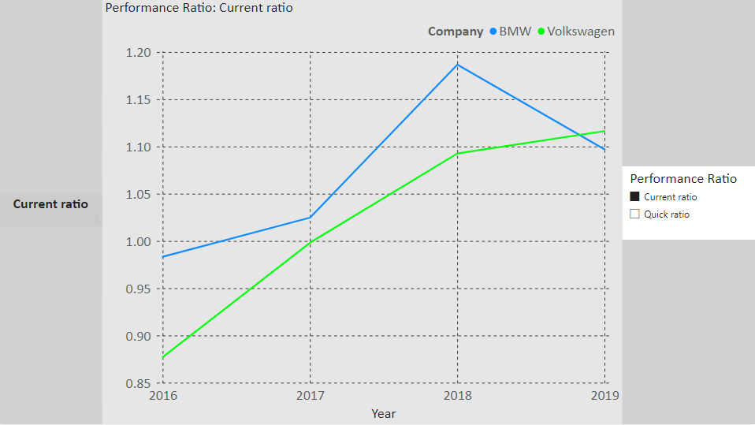  
       
       
      **Observations:**  
     - BMW's current ratio shows a steady improvement from 2016 to 2018, reaching its peak in 2018 (1.18). However, it slightly declines in 2019.  
       
     - Volkswagen's current ratio follows a similar upward trend, but remains lower than BMW's throughout the period. In 2019, Volkswagen's current ratio reaches 1.12, which is closer to BMW's but still behind.  
       
       
       
       
       
       
     4.2.2 Quick Ratio  
       
       
     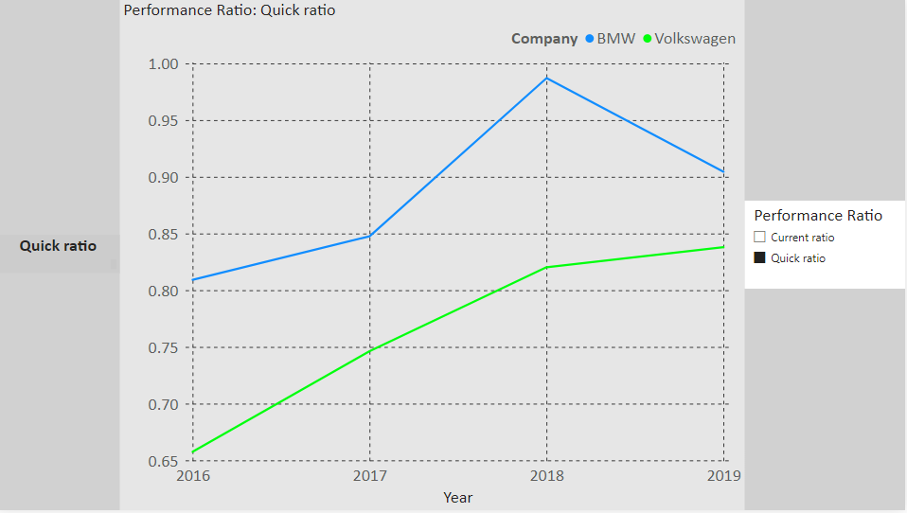  
       
      **Observations:**- BMW's quick ratio remains higher than Volkswagen's throughout the period, peaking in 2018 and declining slightly in 2019.  
       
     - Volkswagen's quick ratio shows a steady improvement but remains below 0.85 for all years, indicating that it might struggle to cover its short-term liabilities without selling inventory.
  2. Activity Ratios  
       
     4.3.1 Asset Turnover  
       
       
     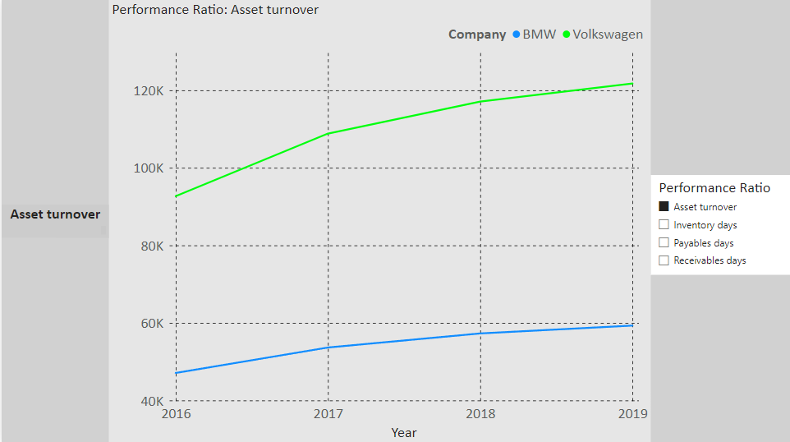  
       
       
       
     **Observations:**- BMW's asset turnover ratio increases moderately from 2016 to 2019, showing better utilization of its assets over time.  
       
       
     - Volkswagen consistently has a higher asset turnover ratio than BMW, with a significant lead over the entire period. In 2019, Volkswagen's asset turnover reaches more than 120,000 which is nearly twice that of BMW.  
       
       
       
       
       
       
       
     4.3.2 Inventory Days  
       
       
     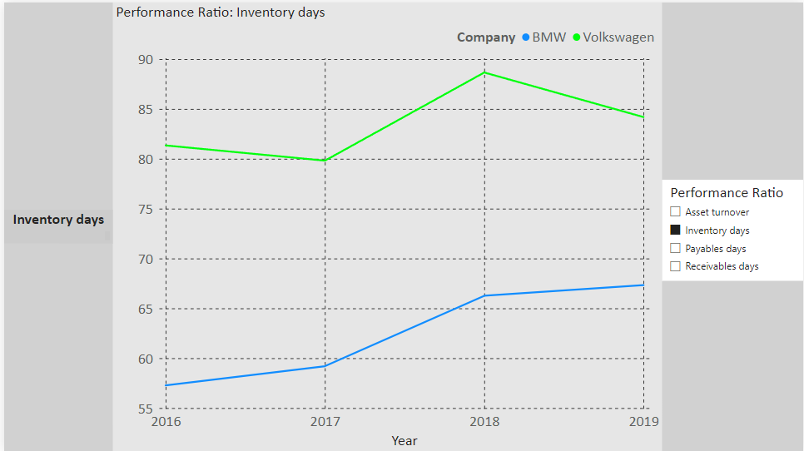  
       
      **Observations:**  
       
     - BMW's inventory days increase from 57 days in 2016 to 67 days in 2019, showing that it is holding onto inventory for longer.  
       
       
     - Volkswagen's inventory days fluctuate but remain higher than BMW's throughout the period, indicating that Volkswagen holds onto its inventory for a longer duration than BMW.  
       
       
       
       
       
       
       
       
       
       
     4.3.3 Payable Days  
       
       
     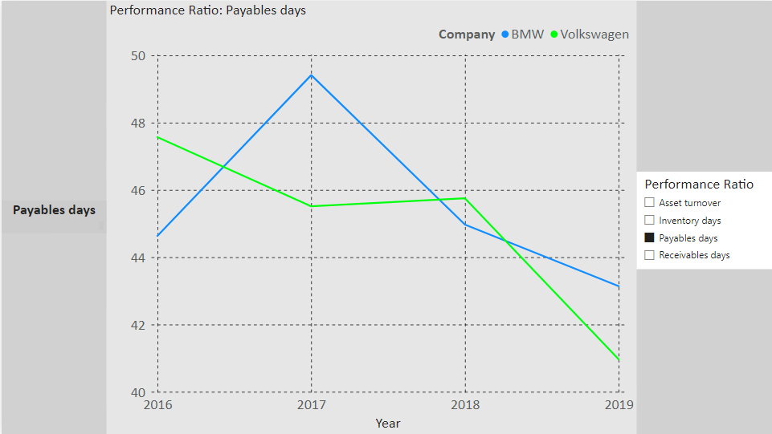  
       
       
       
     **Observations:**- BMW's payables days fluctuate over the years but show a slight decline from 2018 to 2019, meaning it is paying its suppliers more quickly over time.  
       
     - Volkswagen's payables days show a gradual decrease, with the lowest value (40.96 days) in 2019.  
       
       
       
       
       
       
       
       
       
       
     4.3.4 Receivable Days  
       
       
     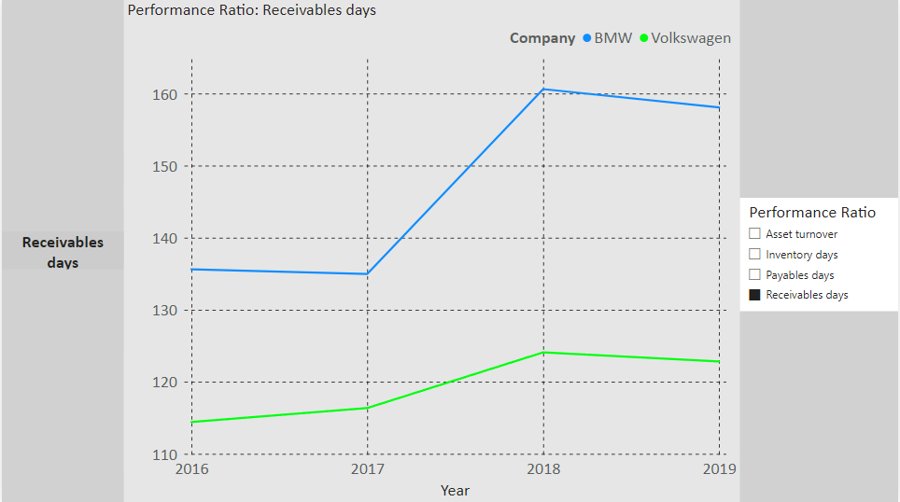  
       
       
       
     **Observations:**- BMW's receivables days steadily increase from 135 days in 2016 to 158 days in 2019, indicating that it takes longer to collect payment from customers over time.  
       
     - Volkswagen's receivables days also increase, but at a slower pace. In 2019, it takes Volkswagen around 123 days to collect receivables, still lower than BMW.
  3. Solvency Analysis  
       
       
     4.4.1 Debt-to-Equity Ratio  
       
       
     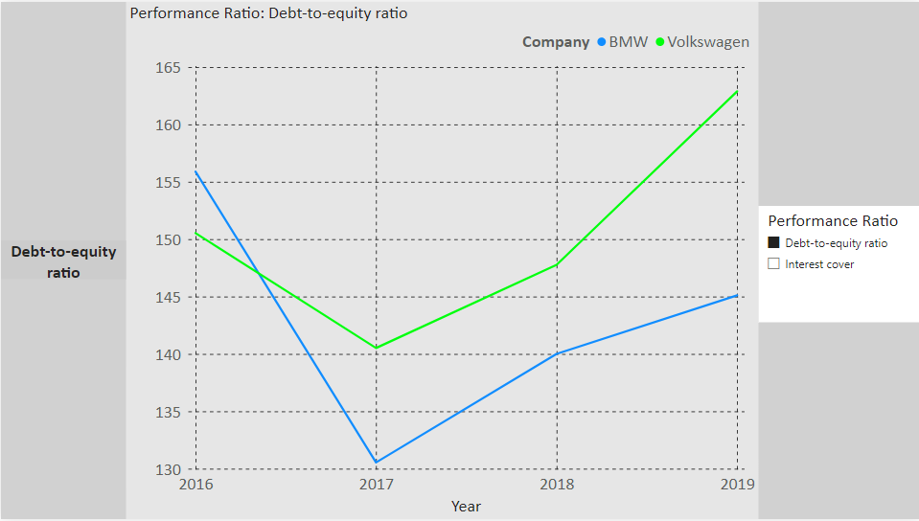  
       
       
       
     **Observations:**- BMW’s debt-to-equity ratio starts off higher than Volkswagen in 2016 but has a huge drop in 2017. This could indicate that BMW started relying more on equity for financing which is safer but could lower the potential returns.  
       
     - Volkswagen’s debt-to-equity ratio also has a small drop in 2017 but increases steadily over the next 2 years. This indicates that the company started relying more on debt for financing which can increase returns in good times.  
       
       
       
       
     4.4.2 Interest Cover  
       
       
     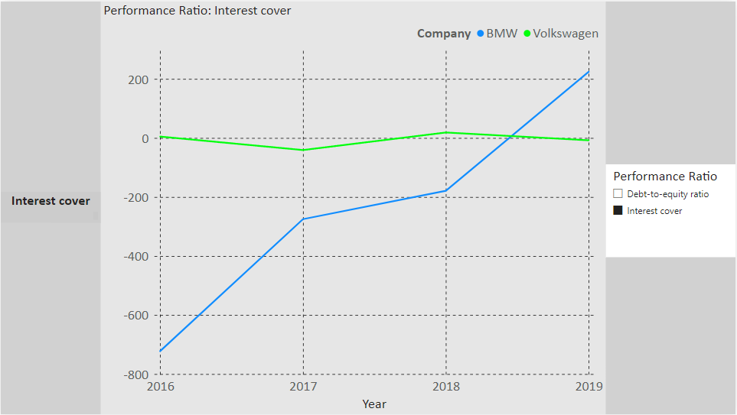  
       
       
       
     **Observations:**- BMW’s interest cover ratio is in deep negative in 2016 which is normally concerning and could indicate that the company is not profitable and may struggle in meeting its debt obligations. However, for a big established company like BMW, this could mean they might have been investing heavily into growth areas. The interest cover ratio increased steadily till 2019 where the interest cover became positive.  
       
     - Volkswagen’s interest cover ratio is hovering close to zero but remains positive, indicating the company is generating just enough operating profit to cover its interest expenses.

1. CONCLUSION

The financial performance of BMW and Volkswagen across profitability, liquidity, activity and solvency ratios reveals some key differences:

* **Profitability**: BMW generally performs better in terms of profitability ratios (Gross Margin, ROCE, ROS) but shows some decline over the years. Volkswagen, on the other hand, maintains relatively stable profitability.
* **Liquidity**: BMW maintains a stronger liquidity position than Volkswagen, particularly in the Quick Ratio, which suggests it has more liquid assets to cover short-term obligations without relying on inventory.
* **Activity**: Volkswagen is more efficient than BMW in terms of asset utilization (Asset Turnover) and managing payables. However, BMW holds inventory for shorter periods than Volkswagen, which may indicate better inventory management.
* **Solvency**: Volkswagen appears to have taken on more debt relative to its equity, which could either be an indicator of more aggressive expansion or potentially higher risk. However, its ability to cover interest payments is stable, meaning its current level of debt is still manageable. BMW on the other hand, relies less on debt but the negative interest cover in 2016 indicates a period of financial distress. However as indicated by the data, BMW can absorb these losses in the short term and continue growing.  
    
  Overall, both companies have their strengths and weaknesses. BMW performs well in profitability and liquidity, while Volkswagen outshines in asset management and efficiency. Volkswagen’s higher reliance on debt indicates a more aggressive but potentially riskier financial strategy.  
    
    
    
    
    
    
    
  6 FUTURE SCOPE  
    
    
    
  This project could be extended in several ways to deepen the analysis and provide more actionable insights:
* **Benchmarking Against Industry**: Compare BMW and Volkswagen's ratios against industry averages or other competitors to provide more context about their performance.
* **Financial Forecasting**: Use time series analysis and forecasting techniques (such as ARIMA or exponential smoothing) to predict future performance based on historical data.
* **Non-Financial Metrics**: Incorporate non-financial metrics like customer satisfaction, sustainability indices, or innovation scores to provide a more holistic view of the companies' overall performance.
* **Seasonality Analysis**: Explore the possibility of seasonal trends in the activity ratios, especially for the automotive industry where sales can be affected by specific periods (e.g., year-end sales)

1. REFERENCES

The following websites have been referred to obtain the input data and statistics:

1. <https://docs.google.com/spreadsheets/d/e/2PACX-1vTjcQJJAzAF6zzJrmKiKLc8BVlkTVGmz_pBN3ZACAK3QWuM0fWIm3IfAkChwUt1JjtJywz2Fnz4aFVP/pubhtml> - Data used for analysis sourced from this link
2. **Financial Ratios Analysis** – Eugene F. Brigham, Michael C. Ehrhardt, *Financial Management: Theory & Practice*. – Provided some   
   understanding of financial ratios and their interpretations.
3. Power Bi – The use of this software was learnt from a Coursera course as well as the official documentation for Power Bi - <https://learn.microsoft.com/en-us/power-bi/>